Performance and its Urban Context

24 March 2018
University of Sheffield

We invite proposals for 20-minute presentations on early performance cultures and their urban context. We welcome papers focusing on English and non-English traditions from roughly 500 to 1600. Topics covered could include, but are not limited to:
- the importance of urban topography for performances
- the role of performances in creating and/or representing civic identity
- the role of performances in creating and/or representing civic unity
- the connections between performances and civic dissent
- the importance of (inter-)urban networks for performances
- the movement of performative artefacts and/or actors between cities and/or other institutions
- the use of performance in political activities within cities or between cities and other entities
- representations of urban environments in performances

Please send 200-word abstracts to c.steenbrugge@sheffield.ac.uk by Tuesday 31 October 2017.
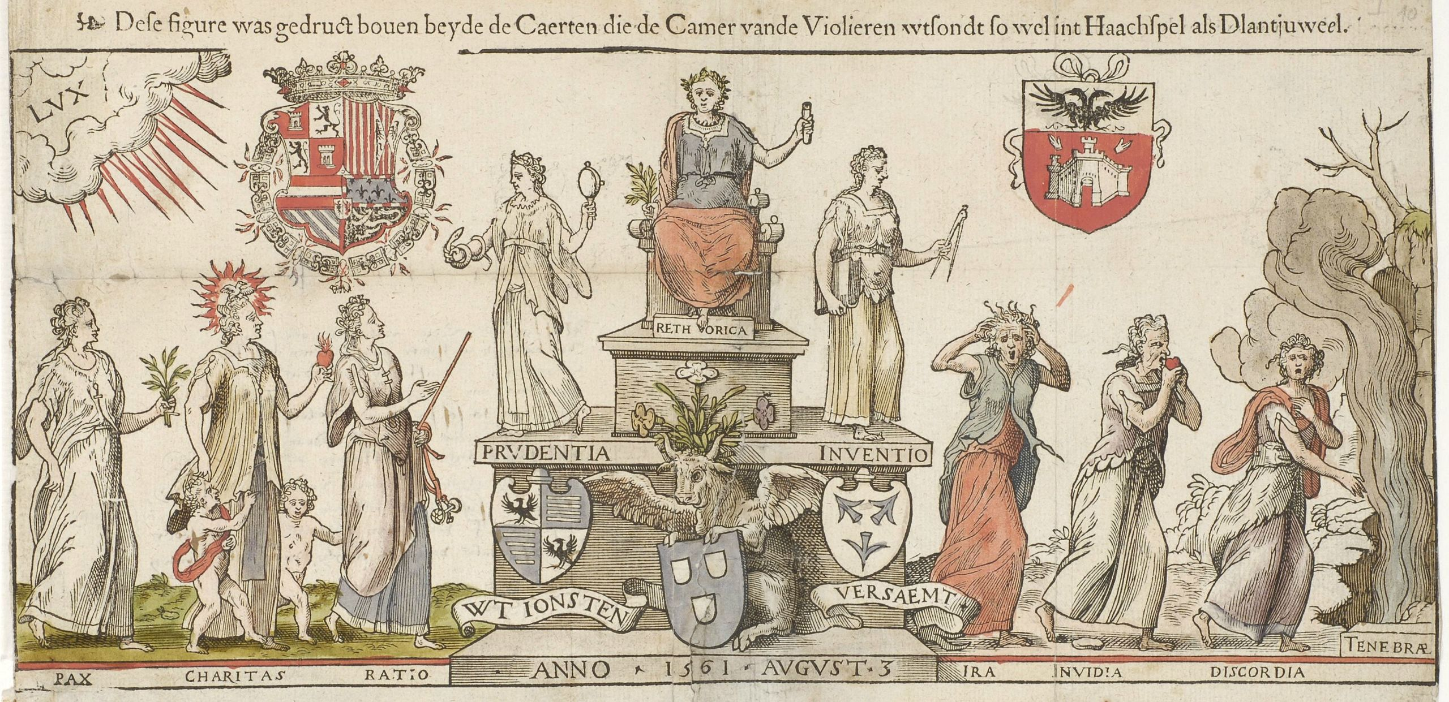
Antwerp rhetoricians invite other chambers of rhetoric to a competition (1561)

